Evaluating the Relationship Between Fan Sentiment and Team Performance: A Multi-Team Analysis of MLB Subreddit Data
Abstract
This report evaluates the relationship between fan sentiment expressed in Major League Baseball team subreddits and team performance outcomes during the 2025 season. Reddit posts and comments were collected for eight MLB teams and paired with game-level performance data. Sentiment was measured using several complementary components, including VADER-style sentiment, sports-domain sentiment, TF-IDF-based scoring, and a final combined sentiment measure. The study finds that fan sentiment is meaningfully associated with performance, but the relationship is moderate, asymmetric, and context-dependent. Recent performance is more strongly associated with sentiment than cumulative season success, and win days generally produce higher sentiment than loss days. However, performance explains only a minority of sentiment variation, showing that fan sentiment also reflects expectations, identity, engagement dynamics, and broader team narratives.
Introduction
The rise of digital platforms has transformed how sports fans engage with teams, players, and game outcomes. Online communities such as Reddit provide real-time spaces where fans express opinions, frustrations, optimism, and reactions to performance. Within Major League Baseball, team-specific subreddits offer a valuable source of unstructured text data because they capture fan discourse across wins, losses, injuries, roster decisions, and season narratives. Unlike traditional surveys or structured fan polls, Reddit discussions are organic, frequent, and highly responsive to current events, making them a useful source for studying public perception in sports.
Advancements in natural language processing make it possible to systematically analyze large volumes of this fan-generated text. Sentiment models allow researchers to classify discourse as positive, neutral, or negative and then aggregate that sentiment across teams and time periods. This project applies sentiment analysis to MLB subreddit posts and comments to examine whether fan sentiment corresponds with team performance outcomes. The study is designed as a correlational analysis rather than a causal analysis; the goal is not to prove that fan sentiment causes teams to win or lose, but to evaluate whether fan sentiment aligns with performance patterns.
Problem Formulation
To what extent does fan sentiment expressed on MLB team subreddits correlate with the performance outcomes of the respective teams? The question is important because fan sentiment is often treated as an informal indicator of organizational health, team momentum, and public confidence. However, fan reactions are shaped by more than wins and losses alone. Expectations, market size, historical success, player-specific narratives, and frustration with management decisions may all influence how fans discuss their teams.
The null hypothesis is that there is no statistically meaningful relationship between fan sentiment and team performance outcomes. The alternative hypothesis is that there is a measurable relationship between sentiment and performance, such that teams performing better tend to have more positive fan sentiment, while teams performing worse tend to have more negative fan sentiment. Because this research uses observational social media data, the study evaluates association rather than causation.
Methods
This study uses a quantitative text analytics approach. Reddit posts and comments were collected for eight MLB team communities and paired with team-level game data. The Reddit data were analyzed using multiple sentiment measures, including VADER-style sentiment, a sports-domain sentiment score, TF-IDF-based indicators, and a final combined sentiment measure. The final sentiment score was used to classify each record as positive, neutral, or negative and to calculate team-level sentiment summaries.
For team performance, game outcomes were retrieved in CSV format from Baseball-Reference.com. The game data include win/loss outcomes, runs scored, and runs allowed. The win/loss field includes standard wins and losses as well as walk-off outcomes, such as W-wo and L-wo. Runs scored and runs allowed support additional performance indicators such as run differential, which provides a more nuanced measure of team strength than binary win/loss outcomes alone.
The analytical strategy aligns sentiment aggregates with performance outcomes at the team and game-day levels. Pearson correlation coefficients evaluate linear association, p-values assess statistical significance, Cohen's d interprets win-day versus loss-day effect size, and R-squared values estimate how much sentiment variation can be explained by performance metrics. This makes it possible to evaluate whether sentiment follows cumulative performance, short-term momentum, specific game outcomes, or broader team context.
Dataset and Preprocessing
The Reddit dataset was obtained using Arctic Shift and includes posts and comments from the Chicago White Sox, Colorado Rockies, Milwaukee Brewers, Minnesota Twins, New York Yankees, Philadelphia Phillies, Toronto Blue Jays, and Washington Nationals subreddits. Raw Reddit data were stored as JSONL files using the naming convention data/r_<SUBREDDIT>_posts.jsonl and data/r_<SUBREDDIT>_comments.jsonl.
The preprocessing workflow consisted of two major stages. First, preprocess_reddit.py sampled posts and comments from the raw JSONL files and retained only relevant fields. Second, clean_data.py cleaned and standardized both the MLB CSV files and Reddit JSONL files. The final cleaned datasets were saved under data/clean/mlb/ and data/clean/reddit/. Relevant Reddit fields included score, ups, created, and created_utc. The created and created_utc fields were treated as Unix timestamps and converted into datetime values for temporal alignment. For MLB data, the main fields included W/L, R, and RA.
Results
The sentiment summary includes 380,814 total Reddit records across the eight teams analyzed. The dataset is heavily comment-driven: the combined data include 18,567 posts and 362,247 comments. This imbalance indicates that fan sentiment in the dataset is shaped primarily by discussion and interaction rather than original post creation. Because comments dominate the dataset, the results likely reflect collective conversational dynamics within each fanbase.
Across all teams, positive sentiment represented the largest category for every subreddit, but the percentage varied across fanbases. The COL subreddit had the highest share of positive sentiment at 48.85%, while the NYY subreddit had the lowest share of positive sentiment at 43.17%. The NYY subreddit also had the highest share of negative sentiment at 29.37%, while the TOR subreddit had the lowest negative sentiment at 23.34%.
The mean final sentiment score was positive for every team, although the magnitude was modest. The COL subreddit produced the highest mean final sentiment score (0.0889), while the NYY subreddit had the lowest mean final sentiment score (0.0522). Because mean values are close to zero and median values are near neutral, MLB subreddit sentiment is generally balanced, with positive and negative reactions occurring alongside a substantial amount of neutral discussion.
Team-Level Sentiment Summary
Team | Records | Posts | Comments | Mean Final | % Positive | % Neutral | % Negative
CHW | 47,485 | 2,215 | 45,270 | 0.0883 | 47.24% | 27.30% | 25.47%
COL | 48,516 | 2,132 | 46,384 | 0.0889 | 48.85% | 24.89% | 26.27%
MIL | 46,391 | 2,334 | 44,057 | 0.0887 | 45.21% | 31.40% | 23.39%
MIN | 47,945 | 2,167 | 45,778 | 0.0648 | 43.82% | 29.20% | 26.98%
NYY | 47,869 | 2,480 | 45,389 | 0.0522 | 43.17% | 27.46% | 29.37%
PHI | 47,345 | 2,530 | 44,815 | 0.0620 | 43.24% | 29.63% | 27.13%
TOR | 46,961 | 2,366 | 44,595 | 0.0841 | 44.88% | 31.78% | 23.34%
WSN | 48,302 | 2,343 | 45,959 | 0.0886 | 47.34% | 27.28% | 25.37%
Table 1. Team-level Reddit sentiment summary for the eight MLB subreddits included in the study.
Temporal Sentiment and Performance Patterns
The time-series visualization demonstrates that sentiment changes throughout the season rather than remaining constant. Across teams, the seven-game rolling sentiment line moves in patterns that often correspond with cumulative performance, but the pattern is not identical for every team. Some fanbases show relatively smooth changes, while others demonstrate sharper peaks and dips. The temporal plots also show asymmetry: negative sentiment can emerge rapidly during losing stretches or after poor performances, while positive sentiment tends to accumulate more gradually during periods of success.
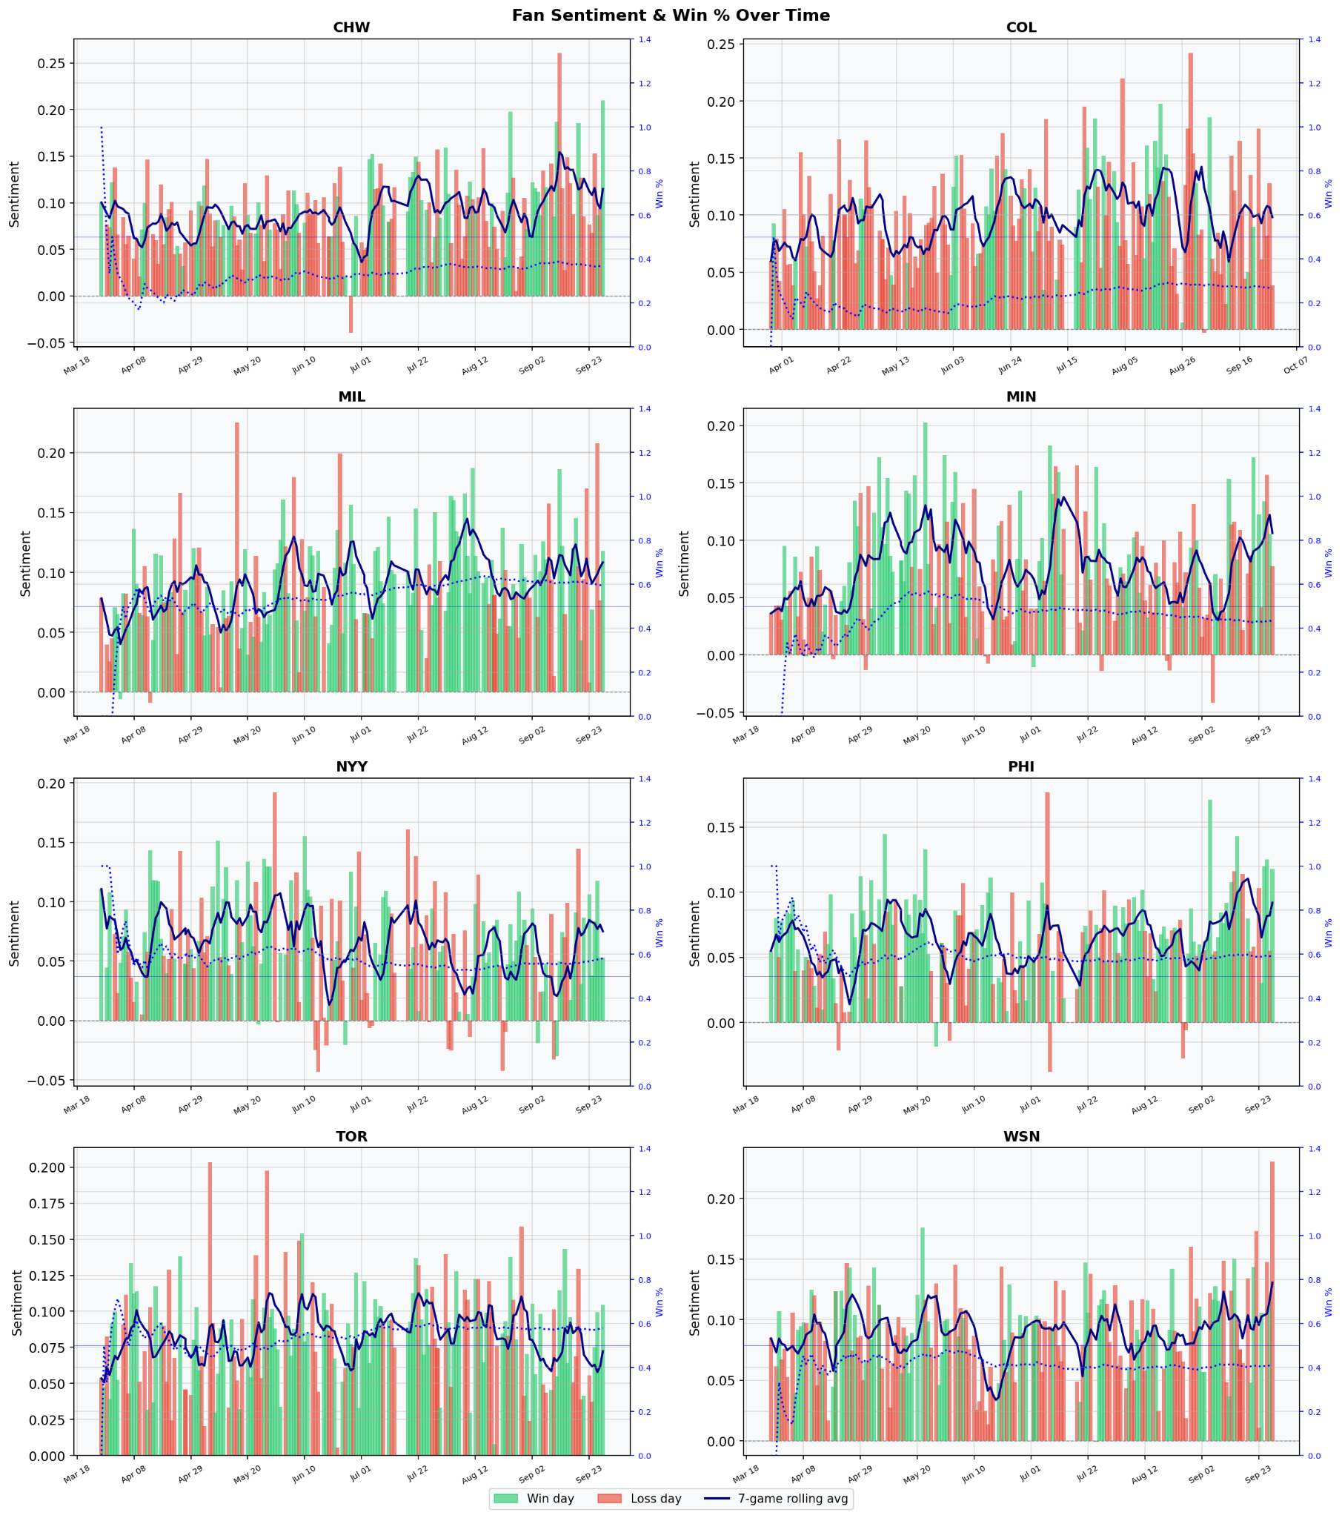
Figure 1. Fan Sentiment and Win Percentage Over Time. Daily sentiment bars and seven-game rolling sentiment are plotted against cumulative win percentage for each team, showing that fan sentiment changes with the rhythm of the season but does not move identically across fanbases.
Correlation Between Sentiment and Cumulative Win Percentage
The correlation between game-day sentiment and cumulative win percentage is positive for every team, but the strength of the relationship varies considerably. Milwaukee had the strongest cumulative win percentage correlation with sentiment (r = 0.28, p < 0.001), followed closely by the Chicago White Sox (r = 0.27, p = 0.001) and Minnesota (r = 0.26, p = 0.001). Colorado also showed a significant positive relationship (r = 0.20, p = 0.012), while the New York Yankees had a weaker but statistically significant association (r = 0.17, p = 0.034).
By contrast, Philadelphia (r = 0.05, p = 0.555), Toronto (r = 0.12, p = 0.128), and Washington (r = 0.14, p = 0.081) did not show statistically significant cumulative win percentage relationships. This means that cumulative success alone does not explain fan sentiment equally across teams. In some communities, overall season performance aligns with emotional tone; in others, fan discourse appears to be shaped more strongly by recent outcomes, expectations, roster context, or community norms.
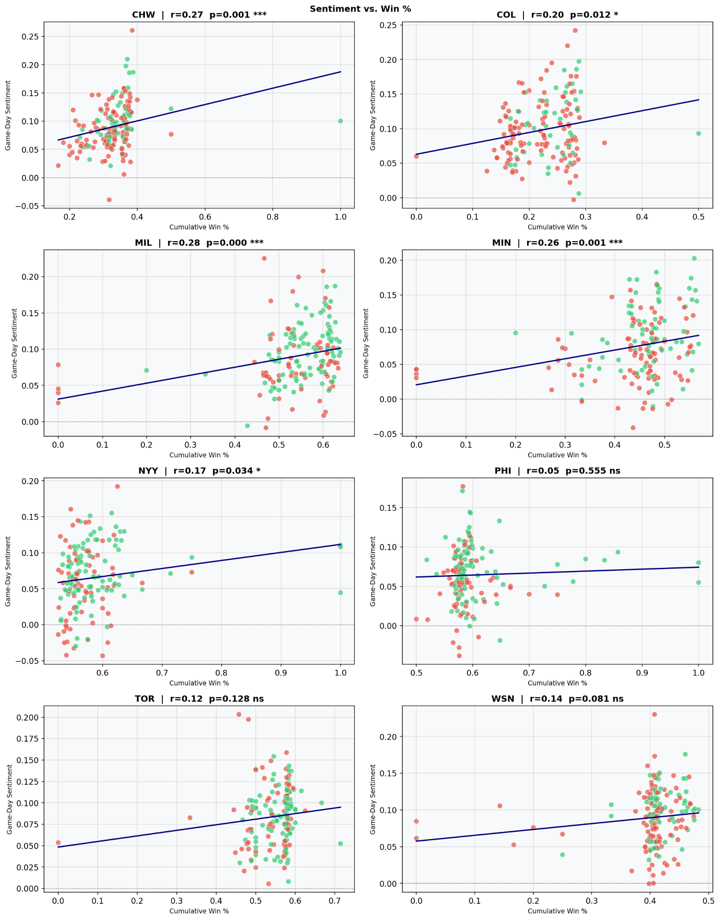
Figure 2. Game-Day Sentiment versus Cumulative Win Percentage. Pearson correlations show positive but modest relationships between sentiment and cumulative performance, with statistically significant associations for CHW, COL, MIL, MIN, and NYY.
Win-Day and Loss-Day Sentiment Differences
The win-versus-loss sentiment distributions provide a clearer view of how fans respond directly to outcomes. Across all teams, average sentiment is higher on win days than on loss days. Minnesota shows the largest win-loss sentiment gap, with a mean difference of +0.029 and a large effect size (d = 0.62, p < 0.001). Philadelphia also shows a large effect (mean = +0.019, d = 0.56, p < 0.001). Milwaukee, the Yankees, Washington, and the White Sox show smaller but meaningful effects. Colorado has a smaller, non-significant gap, and Toronto shows almost no win-loss sentiment separation.
These differences suggest that fanbases vary in reactivity. Some teams have fans whose sentiment changes noticeably depending on whether the team wins or loses. Other communities, especially Toronto in this dataset, appear less reactive to game outcomes, meaning discussion sentiment may be driven more by broader narratives, player-specific discussion, or longer-term expectations than by single-game results.
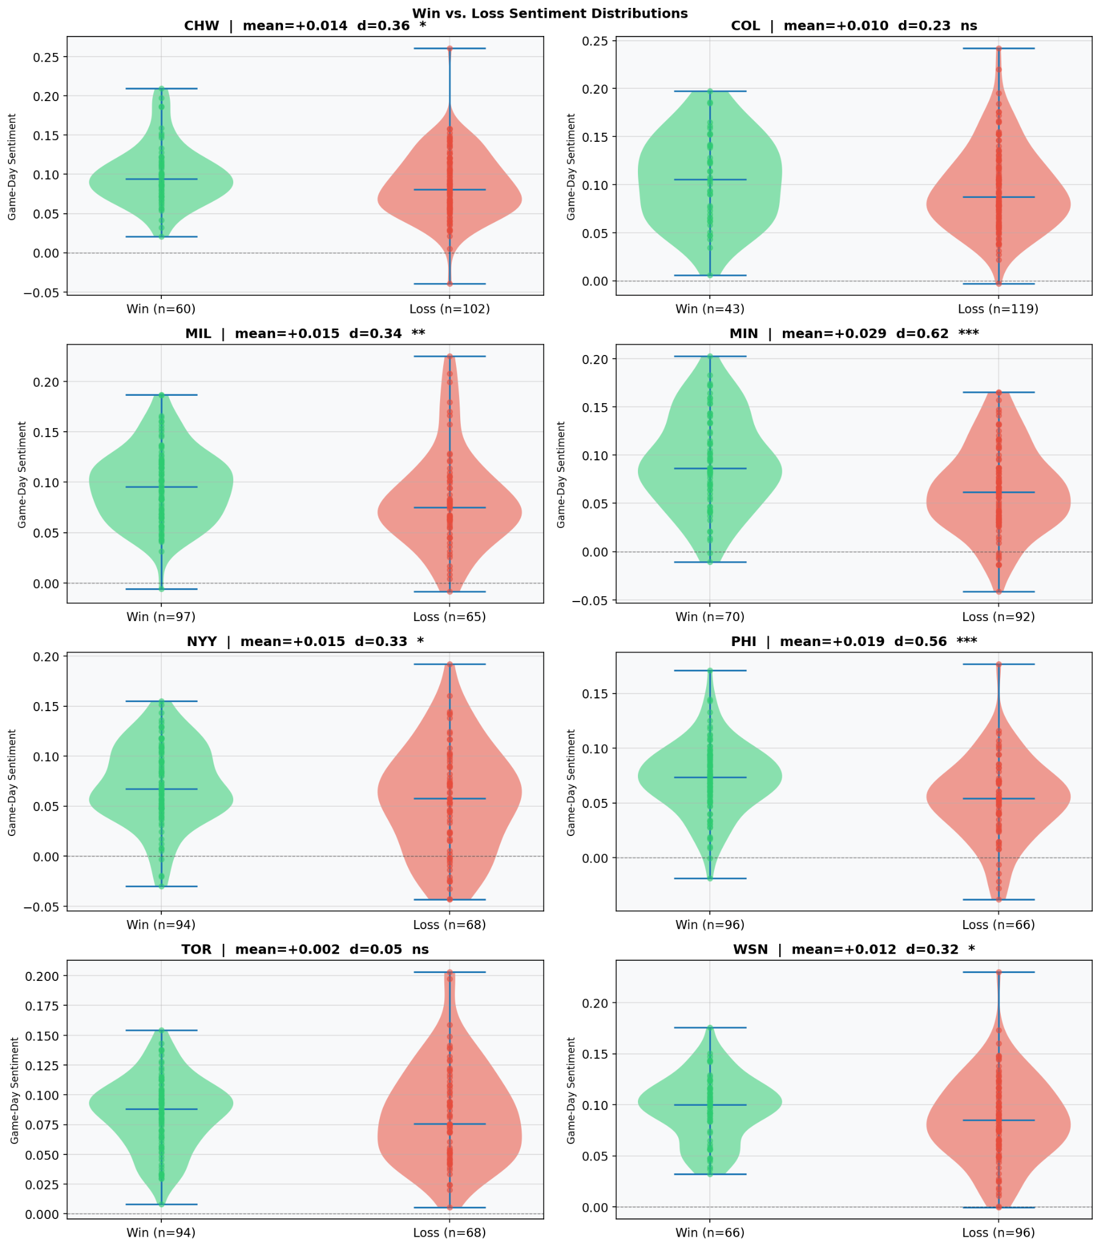
Figure 3. Win-Day versus Loss-Day Sentiment Distributions. Sentiment is consistently higher on win days than loss days, with the largest effects for Minnesota and Philadelphia and the smallest difference for Toronto.
Recent Performance as a Stronger Sentiment Driver
The strongest and most consistent pattern emerges when sentiment is compared against last-five-game win percentage. Recent performance correlates more strongly with sentiment than cumulative win percentage for nearly every team. Colorado shows the strongest association with recent performance (r = 0.41, p < 0.001), followed by Washington (r = 0.39, p < 0.001), Minnesota (r = 0.37, p < 0.001), the Yankees (r = 0.34, p < 0.001), Milwaukee (r = 0.32, p < 0.001), Philadelphia (r = 0.30, p < 0.001), and the White Sox (r = 0.26, p < 0.001). Toronto again shows the weakest relationship, though it remains statistically significant (r = 0.17, p < 0.05).
This finding is central to the study because it suggests that fan sentiment is more responsive to recent momentum than to season-long performance. A team may have a strong overall record, but if the team has struggled in the most recent series, fan sentiment may decline. Conversely, a weaker team may experience improved sentiment during a short winning stretch.
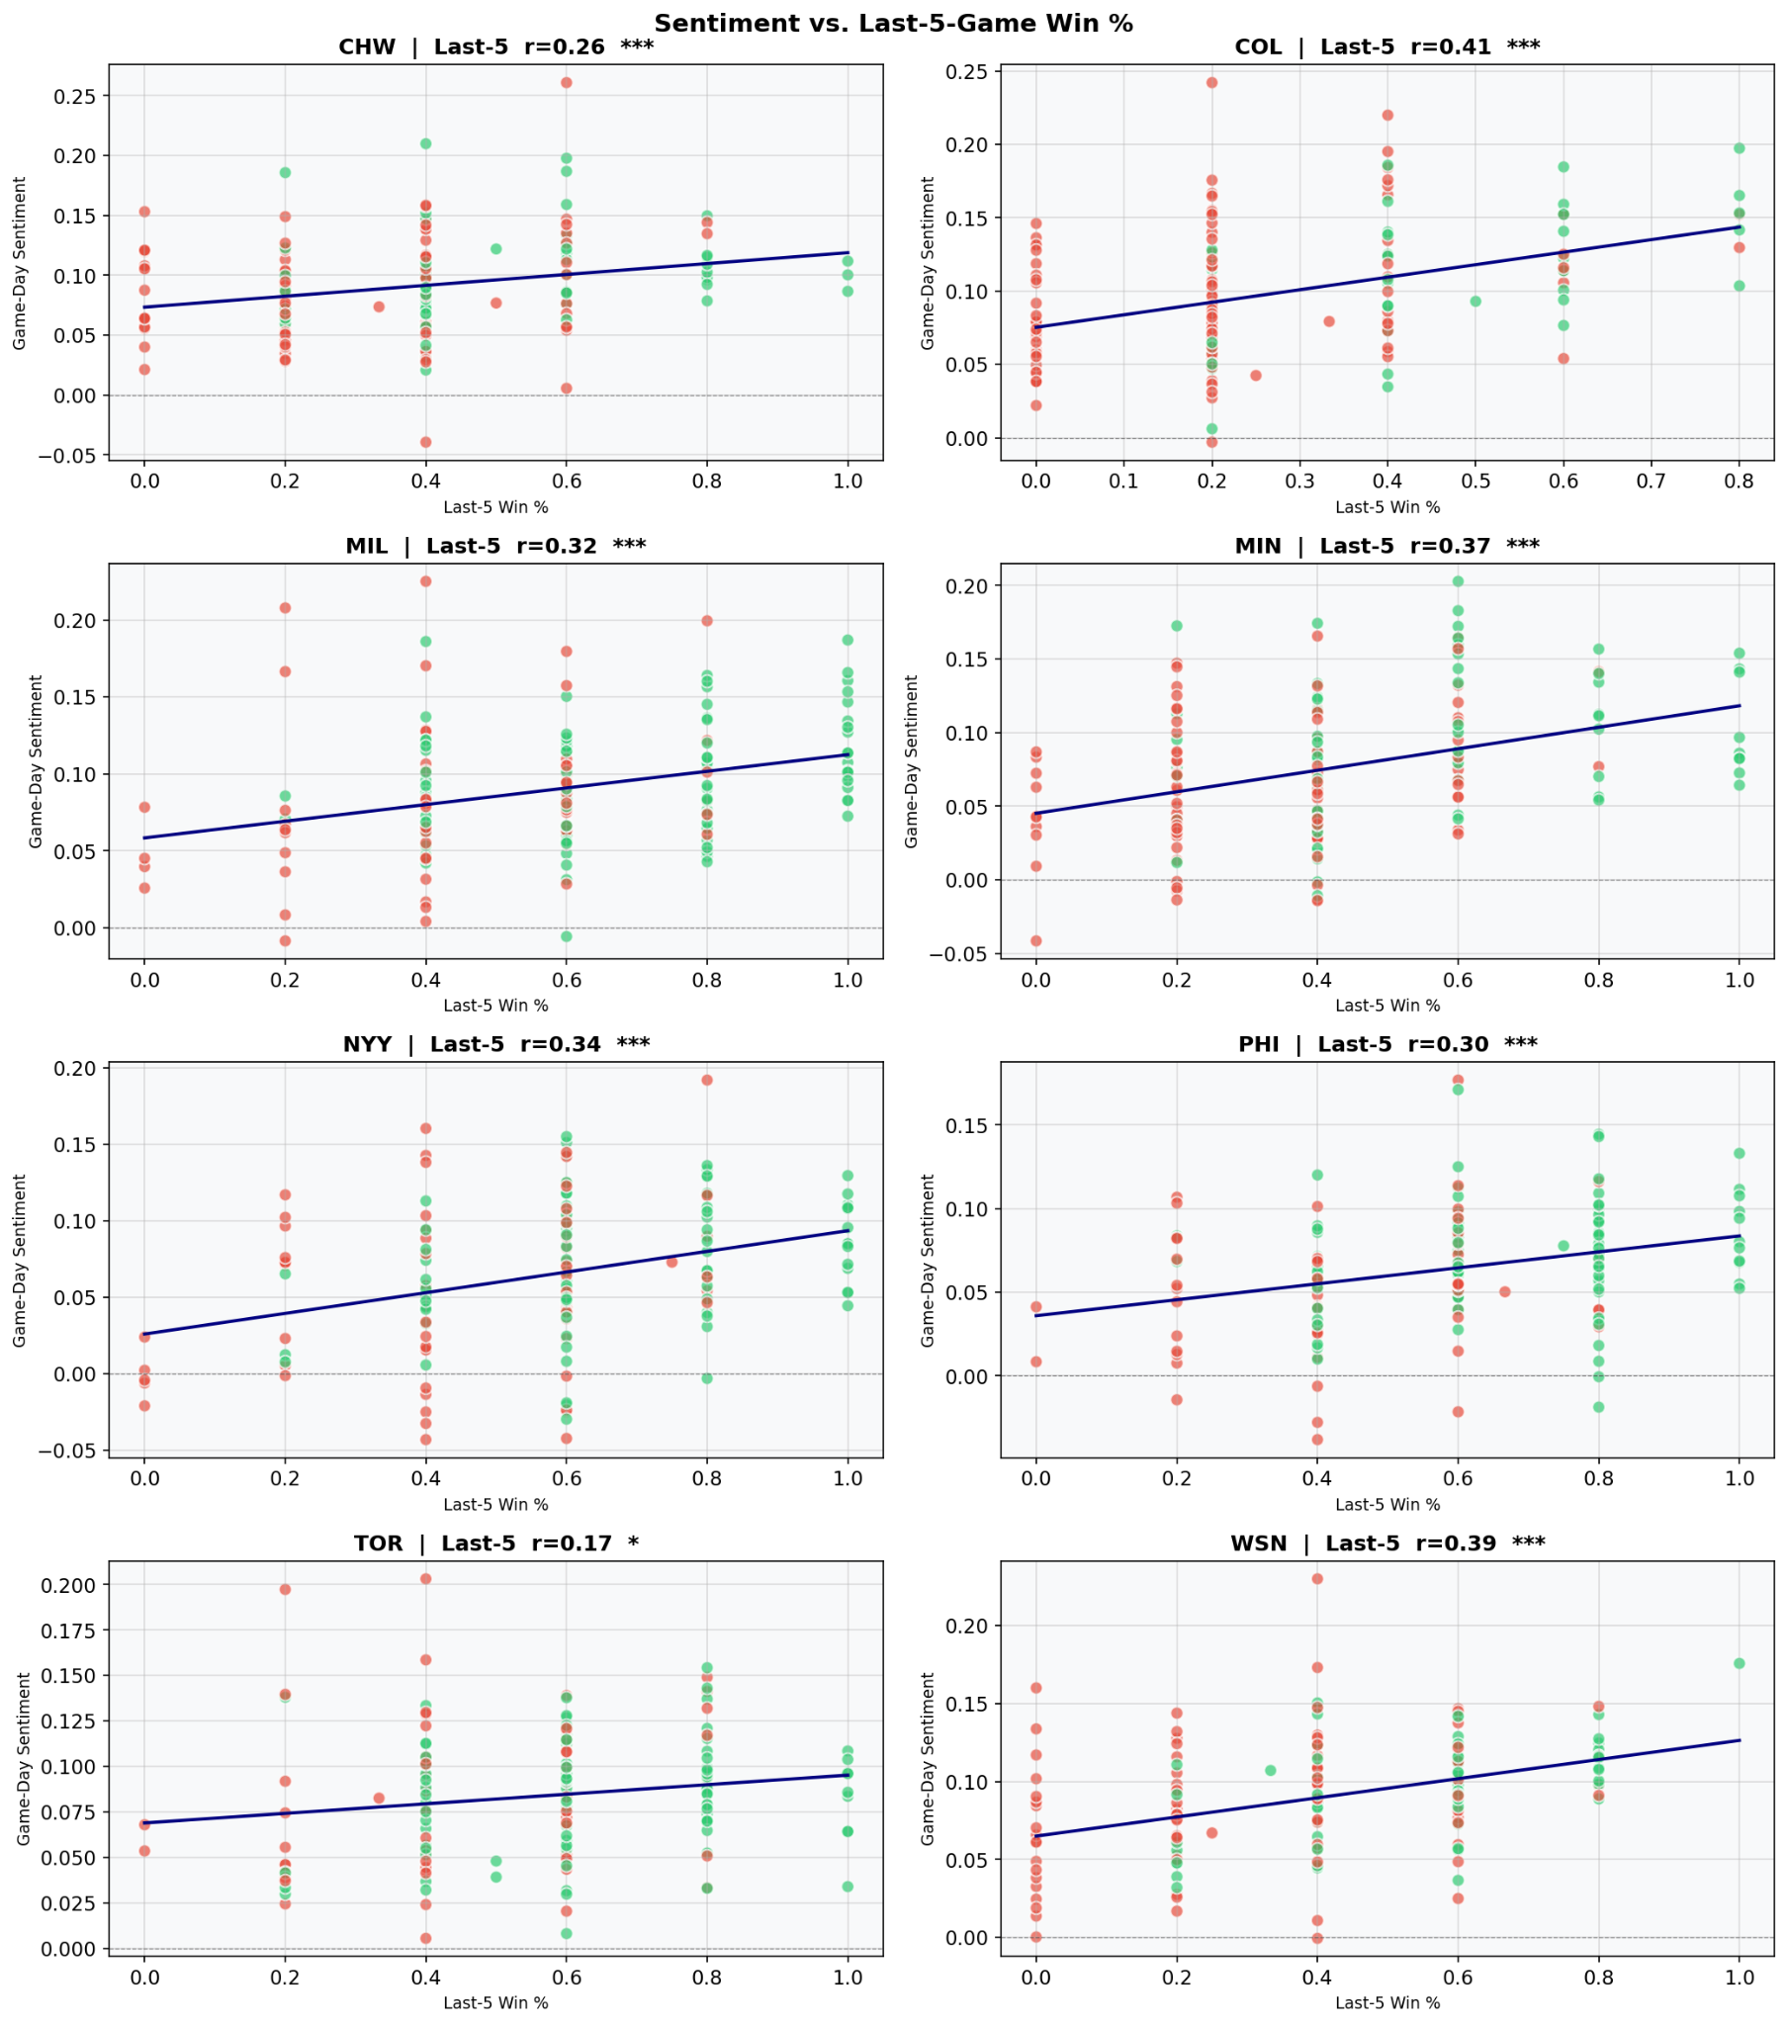
Figure 4. Sentiment versus Last-Five-Game Win Percentage. Recent performance has stronger and more consistent relationships with sentiment than cumulative season performance, indicating that fan sentiment is particularly responsive to short-term momentum.
Cross-Team Reactivity and Explanatory Power
The cross-team reactivity analysis further clarifies how different fanbases respond to performance. Minnesota is the most reactive fanbase in the dataset, with the largest win-day minus loss-day sentiment gap (+0.029), followed by Philadelphia (+0.019), Milwaukee and the Yankees (+0.015), the White Sox (+0.014), Washington (+0.012), Colorado (+0.010), and Toronto (+0.002).
The R-squared panel shows that performance explains only a portion of sentiment variation. Washington has the highest explanatory value, with performance accounting for approximately 19.8% of sentiment variation. Colorado follows at 17.4%, the Yankees at 16.8%, Minnesota at 15.6%, Philadelphia at 15.3%, Milwaukee at 12.2%, the White Sox at 8.7%, and Toronto at only 3.4%. Even in the strongest case, more than 80% of sentiment variation remains unexplained by performance alone. This is an important finding because it demonstrates that sentiment is not a simple reflection of wins and losses.
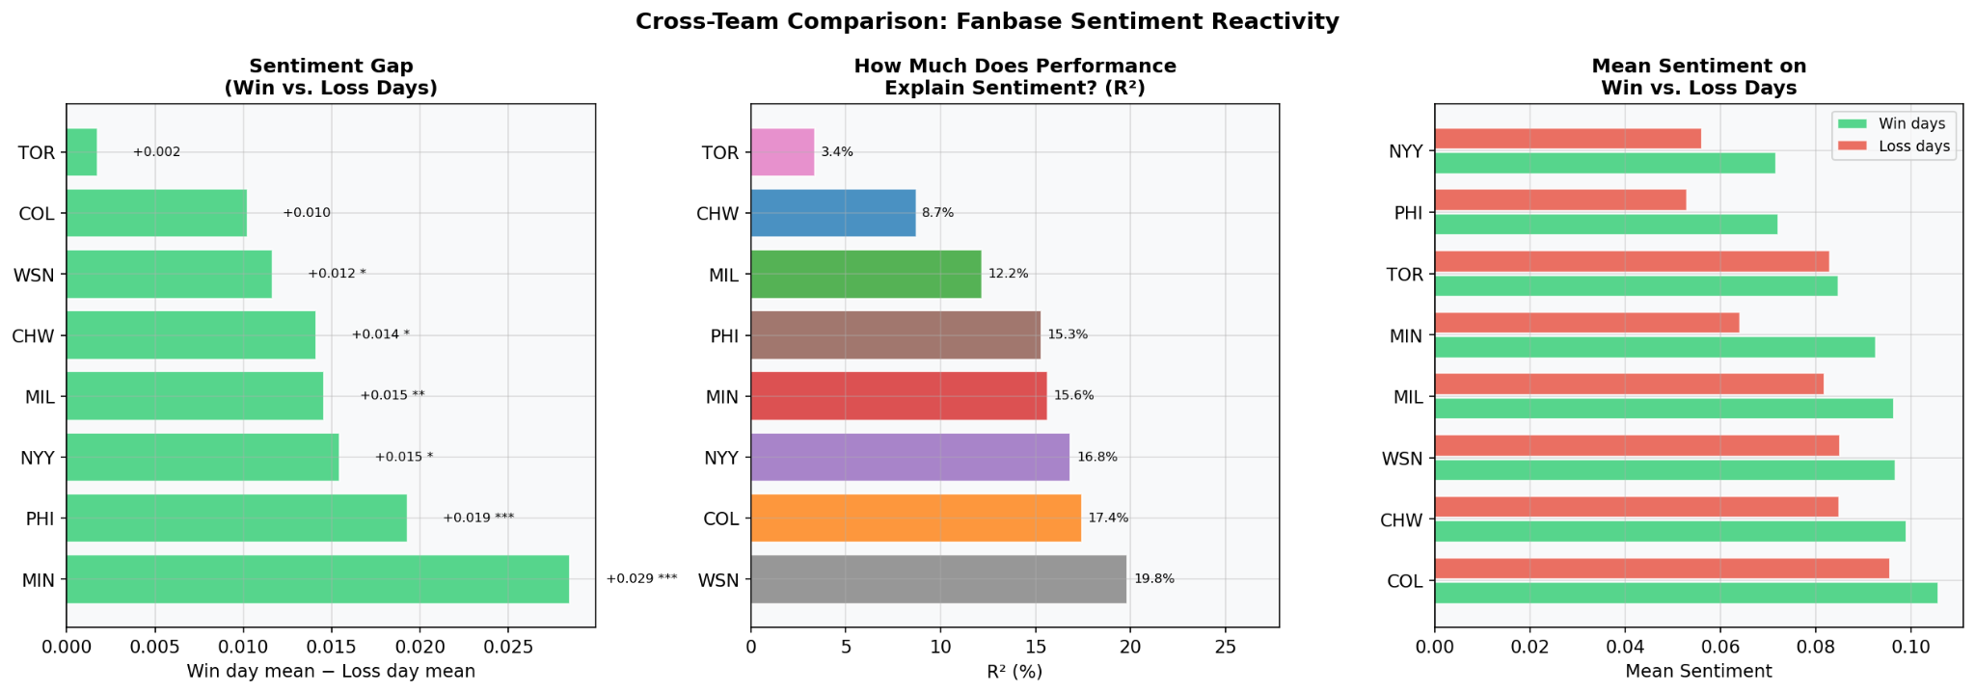
Figure 5. Cross-Team Comparison of Fanbase Sentiment Reactivity. Minnesota shows the largest win-loss sentiment gap, Washington has the highest percentage of sentiment explained by performance, and Toronto shows the weakest performance-sentiment connection.
Alignment, Reactivity, and Performance Metrics
The heatmap extends the correlation analysis by comparing sentiment to multiple performance metrics: cumulative win percentage, last-five-game win percentage, run differential, and streak. The heatmap shows that last-five-game win percentage is the most consistently strong metric across teams. Run differential is generally weaker, with several teams showing near-zero relationships, such as Toronto and Washington. Streak also performs relatively well, especially for Philadelphia, Minnesota, the Yankees, and Washington.
The reactivity-versus-alignment scatterplot positions each team according to two dimensions: how much performance explains sentiment and how strongly win days differ from loss days. Minnesota stands out as a highly reactive fanbase, with a large win-loss sentiment gap and relatively strong alignment between sentiment and performance. Philadelphia also shows high reactivity, although its cumulative win percentage correlation is weak, suggesting that Philadelphia fans may respond sharply to outcomes without sentiment necessarily tracking season-long performance. Toronto is the clearest low-reactivity and low-alignment case.
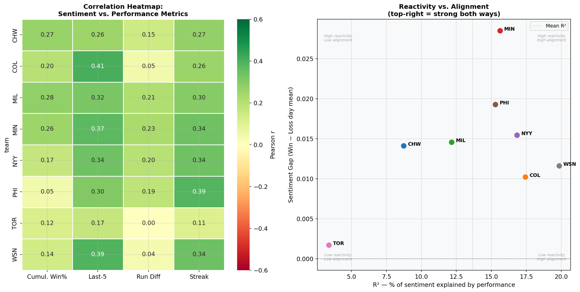
Figure 6. Correlation Heatmap and Reactivity-versus-Alignment Map. Last-five-game win percentage and streaks are more consistently aligned with sentiment than run differential, while teams differ in both alignment and emotional reactivity.
Sentiment Components by Outcome
The component-level analysis shows that the final combined sentiment score is consistently higher on win days than on loss days. This pattern holds across teams and across several input components, including VADER, TF-IDF, and the final score. The sports-domain component is more variable and frequently closer to zero or negative, which suggests that sports-specific vocabulary may capture frustration and criticism that general sentiment tools interpret differently.
This finding supports the robustness of the final sentiment measure. If only one model component showed win-loss separation, the results might be sensitive to model choice. Instead, the broader pattern across components indicates that outcome-related sentiment differences are not merely artifacts of a single scoring method.
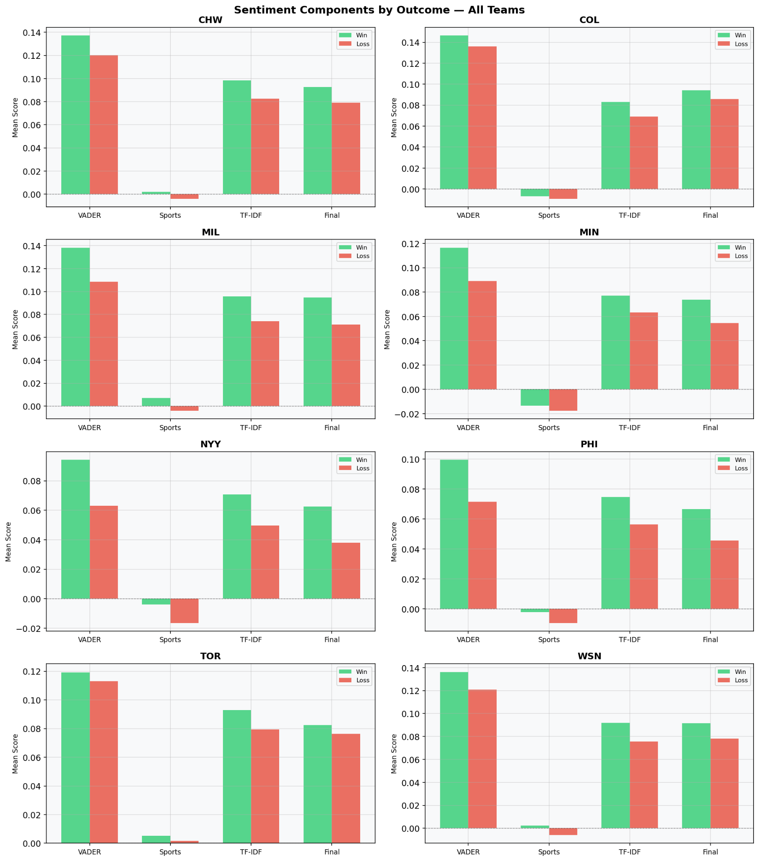
Figure 7. Sentiment Components by Outcome. VADER, TF-IDF, and final sentiment components are generally higher on win days than loss days, supporting the robustness of the final combined sentiment metric.
Correlation Interpretation and Performance Relationship
Taken together, the results show that fan sentiment and team performance are related, but the relationship is moderate rather than deterministic. The cumulative win percentage correlations range from weak and non-significant to modest and significant. The last-five-game correlations are more consistently significant and stronger. This distinction is critical: fans appear to react more strongly to what has happened recently than to the full-season trajectory.
The explanatory-power results are particularly important. Performance explains only 3.4% of sentiment variation for Toronto and at most 19.8% for Washington. This means that even when performance matters, most sentiment variation is driven by other factors. These may include preseason expectations, trade rumors, injury concerns, managerial decisions, rivalry games, player development narratives, or broader frustrations with ownership and organizational direction.
Expectation-Performance Gap
One of the most important insights is the expectation-performance gap. The New York Yankees provide the clearest example. The Yankees had the lowest positive sentiment share and the highest negative sentiment share in the team-level summary, even though they were not simply the weakest-performing team in the sample. Their cumulative win percentage correlation with sentiment was positive but modest (r = 0.17), while their last-five-game correlation was stronger (r = 0.34). This suggests that Yankees fans respond strongly to recent performance but also evaluate the team against a high standard of expected success.
By contrast, the Colorado Rockies had the highest positive sentiment share and the highest mean final sentiment score, while also showing meaningful recent-performance alignment. This does not necessarily mean Rockies performance was stronger than Yankees performance. Rather, it suggests that fan discourse may be more forgiving or differently oriented. Fans of teams with lower expectations may express positivity around incremental improvements, individual player success, or hopeful signs for the future.
Analytical Insights
First, the analysis suggests that fan sentiment is reactive but not purely performance-based. Wins and losses matter, and recent outcomes matter even more, but they do not explain all sentiment variation. This makes subreddit sentiment useful as a real-time perception indicator, not as a standalone performance metric.
Second, the analysis shows that short-term momentum is more emotionally salient than cumulative success. Last-five-game win percentage produces stronger and more consistent correlations than cumulative win percentage. Fans appear to process the season through recent memory and immediate emotional context rather than through a stable, long-term assessment of record quality.
Third, the results show that fanbase identity matters. Yankees fans appear more negative relative to their performance context, while Rockies fans appear more positive. Minnesota and Philadelphia are highly reactive to wins and losses, while Toronto is relatively low in both reactivity and alignment. These differences suggest that each subreddit has its own community norms, emotional baseline, and tolerance for disappointment.
Fourth, the comment-heavy structure of the dataset likely amplifies emotional reaction. Because comments far outnumber posts, the dataset captures conversational momentum. A single frustrating event can generate many comments, and those comments may reinforce negativity through interaction. This makes subreddit sentiment valuable for measuring collective reaction, but it also means sentiment can be volatile and concentrated around high-engagement events.
Limitations
This study has several limitations. First, Reddit users are not representative of all MLB fans. Subreddit communities tend to include highly engaged fans, which may produce stronger opinions than would be observed in a broader fan population. Second, sentiment classification models may misclassify sarcasm, humor, profanity, exaggeration, and sports-specific language. Sports discourse often includes ironic praise, emotional slang, and team-specific references that can complicate automated classification.
Third, the analysis is correlational and does not establish causality. Even if sentiment and performance are correlated, this does not mean fan sentiment causes team outcomes. More plausibly, sentiment reacts to performance and to related factors such as injuries, trades, managerial decisions, or playoff expectations. Fourth, although performance variables such as win percentage, last-five-game win percentage, run differential, and streaks are useful, they do not capture all relevant context.
Conclusion
This study evaluates the relationship between MLB team subreddit sentiment and team performance outcomes by combining Reddit posts and comments with team-level baseball data. The results show that fan sentiment is measurable, comparable across teams, and meaningfully different across fan communities. Positive sentiment is the largest category for every team, but the Yankees show the highest negative sentiment and the lowest mean final score, while the Rockies show the highest positive sentiment and highest mean final score.
The core finding is that fan sentiment is moderately associated with team performance, especially recent performance. Last-five-game win percentage is more strongly associated with sentiment than cumulative win percentage, indicating that fans are especially responsive to short-term momentum. Win-day sentiment is consistently higher than loss-day sentiment, demonstrating that game outcomes influence online discourse. However, performance explains only a minority of sentiment variation, which confirms that fan sentiment is also shaped by expectations, identity, engagement, and contextual narratives.
For sports analytics and business intelligence, these findings show that subreddit sentiment can provide valuable insight into fan engagement, satisfaction, volatility, and perception. However, sentiment should not be interpreted as a direct measure of team quality or as a reliable predictor of future outcomes. Instead, it should be used alongside traditional performance metrics to better understand how fans interpret and emotionally process the season.
Works Cited
Arctic Shift. Reddit Data Archive. Arctic Shift, https://arctic-shift.photon-reddit.com.
Baseball-Reference.com. “2025 Major League Baseball Team Game Logs.” Sports Reference LLC, https://www.baseball-reference.com.
Hugging Face. “cardiffnlp/twitter-roberta-base-sentiment-latest.” Hugging Face, https://huggingface.co/cardiffnlp/twitter-roberta-base-sentiment-latest.
Reddit. “MLB Team Subreddit Posts and Comments.” Reddit, https://www.reddit.com.

